Class Exercise 2-3: Add Links

Using the directory hierarchy shown in the following diagram, write out the markup for the following links.

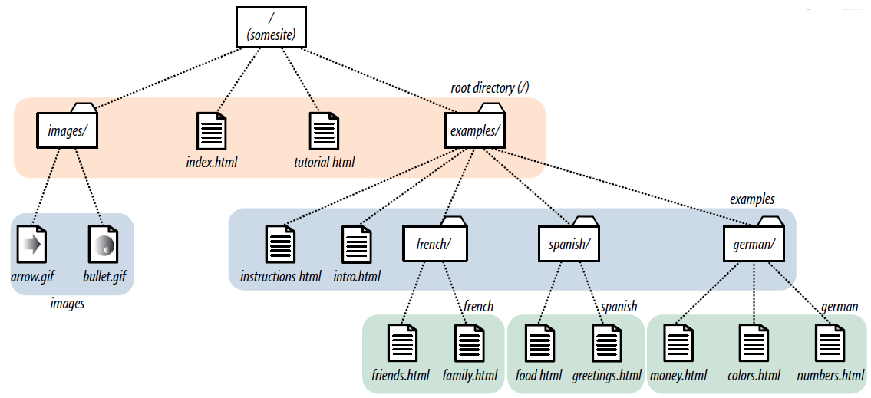

1. In the file index.html, create a link to Yahoo website(www.yahoo.com/).

2. In *index.html* (the site’s home page), write the markup for a link to *tutorial.html*.

3. In *index.html*, write the anchor element for a link to *instructions.html*.

4. Create a link to *family.html* from the page *tutorial.html*.

5. Create a link to *numbers.html* from the *family.html* page, but this time, start with the root directory.

6. Create a link back to the home page (*index.html*) from the page *instructions.html*.

7. In the file *intro.html*, create a link to the website for w3shools website (www.w3schools.com/html/).

8. Create a link to *instructions.html* from the page *greetings.html*.

9. Create a link back to the home page (*index.html*) from *money.html*.